Ecosystem Dynamics: Energy Flow in Ecosystems Name: _________________________
(Read Ch.3.2; pgs. 74-78)

1. Energy is said to flow in a “one-way” direction through an ecosystem. In your own words, describe what that means.
___Energy flows into an ecosystem by sunlight energy. Light energy is converted into chemical energy (food) by producers
___then goes to consumers. Then energy is lost heat from consumers__________

2. What is a food chain?
It is a series of organisms in which energy is transferred from one organism to another.
3. Draw an example of a food chain:
Algae → Glass shrimp → Crayfish → Racoon
4. What is a food web?
A complicated network of feeding interactions (food chains)

5. Why is a food web a more accurate representation of the feeding relationships in an ecosystem than a food chain?
____An organism is rarely food for, or feeds on, just one other organism. A food web shows the whole community, with all
____the different predators feeding on many different prey___________

6. Visual Reading Tool: Food Webs → Create 2 food chains (by adding arrows); Use figure 3.4 to help
- One that connects algae to the alligator. Then create another food chain.
- One that connects saltmeadow grass to the alligator
→ Use 2 different colors to show the two different food chains.
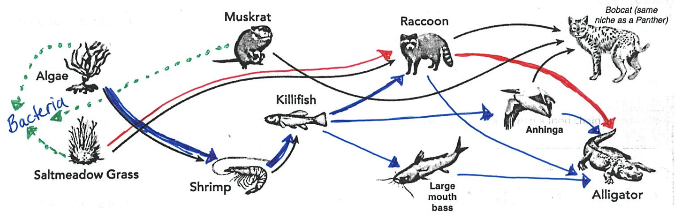

7. Even though alligators do not eat plants, how are primary producers important to the alligator’s energy supply?
Producers convert light energy into usable chemical energy for consumers. The producers indirectly provide food for the
alligators.

8. What is the importance of decomposers and detritivores? What is the difference between the feeding roles?
These two release matter in the form of nutrients that can be used by primary producers. Without them nutrients would
remain locked within dead organisms
Decomposers convert dead material to detritus, which then detritivores eat

9. Properly SHOW a ‘decomposer’ on the diagram of the food web above?
(remember: use the ‘detritus pathway’ on figure 3-4 to help)

Analyzing Data:
A scientist sampled a small cross-section of a grassland ecosystem. Her data for each troohic level are shown in the table below.
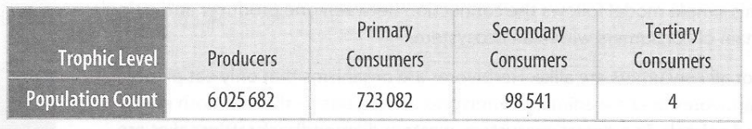

10. Analyze: How does the population size change at each trophic level?
Population size decreases as you move to higher trophic levels

11. Explain: What is the relationship between trophic level and population size?
There are less consumers when moving to higher trophic levels

12. Predict: What would happen if a quaternary (4th level) consumer were added to this ecosystem?
A 4th level consumer would probably not be able to exist (not enough energy)

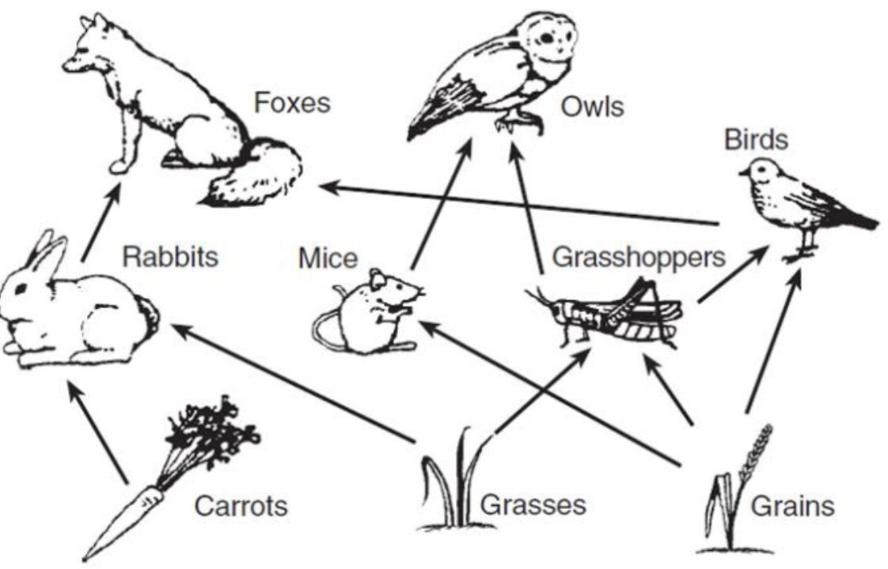
13. Each STEP in a food chain or food web is called a ____Trophic Level_____.

14. What organism always makes up the 1st level?_____Producers_______.

15. List the longest FOOD CHAIN in the diagram to the right.
Grasses/ Grains → Grasshoppers → Birds → Foxes

How many trophic levels are there? __4__

16. Ecological Pyramids → Write the name of each pyramid on the line below and then answer the questions.
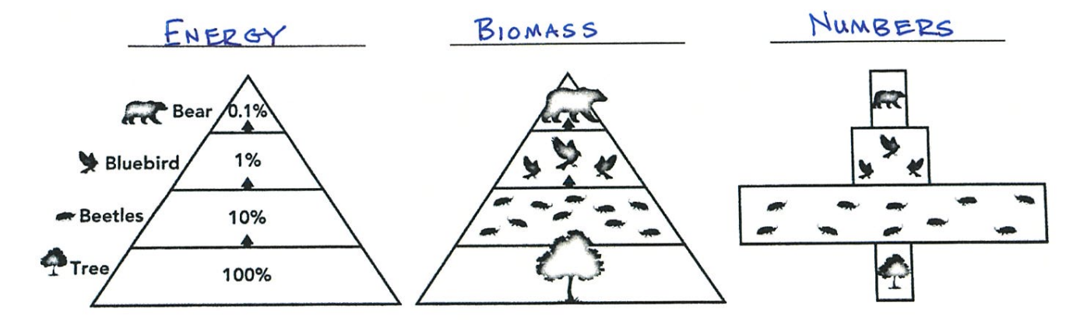

17. What do ALL 3 pyramids have in common?
→ Producers are always at the bottom.
→ In most cases; producers have the most energy, mass & numbers

18. Explain why the biomass at the highest levels of an ecological pyramid decreases?
Less energy is available as trohic levels increase. Less energy = Less animals

19. In this example ecosystem for the pyramids above, describe what would happen to life if one tree was gone?
All the animals in this community cease to exist either by emigration or death

20. Imagine you have a five-step food chain. If 100 percent of energy is available at the first trophic level, what percentage of
energy is available at the highest trophic level? SHOW YOU WORK
100% → 10% → 1 % → 0.1% → 0.01%

